ELECTRICITY, MAGNETISM AND MODERN PHYSICS (PHY121)
ELECTROLYSIS
Electrolysis is the passage of a direct electric current through an ionic substance that is either molten or dissolved in a suitable solvent, resulting in chemical reactions at electrodes and separation of materials. It is the process of using direct current (DC) to initiate a chemical reaction.
Important Terminologies
Anode: This is the positive electrode in a cell.
Cathode: This is the negative electrode in a cell.
Electrolysis: The production of a chemical reaction by the flow of electric current through a solution.
Valence: Represents the net change in electronic units carried by an ion.
Ion: An ion may be either a charged atom or a charged group of atoms.
Electrolyte: This is a substance containing free ions which are the carriers of electric current in electrolysis . It is a substance which conducts electricity in its molten state or in the form of its aqueous solution. Examples of electrolyte are acid, bases and salts like NaOH, KNO₃, HCl, HNO₃ etc.
Non-electrolyte – The substance which does not conduct electricity in its molten state or in the form of its aqueous solution is known as non-electrolyte. For example, cane sugar, urea, glycerine etc.
Chemical Equivalent Weight: The atomic weight of an element divided by its valence is known as the chemical equivalent weight of the element.
Electrodes: These are conductors in the form of wires, rods or plates through which an electric current enters or leaves the electrolyte.
Cations: This are the positively charged ions in an electrolyte.
Anions: These are the negatively charged ions in an electrolyte.
Types of conductors
Conductors are materials through which an electrical current can flow easily i.e.
with low resistance. This can be a metal or an ionic solution or an ionized gas. Generally three types of conductors are metallic, ionic or electrolytic and plasma.
Ionic or Electrolytic conductors - In ionic or electrolytic conductors, positively and negatively charged ions ( cations and anions respectively ) carry the electric current. This transport of material changes the composition of the electrolyte and leads to a chemical reaction in the material such as deposit on the electrode.
When an electrolyte is dissolved in water, it breaks up into positively and negatively charged ions, making the solution an electric conductor. When a potential difference is applied to the two electrodes, the battery or generator of electric current pumps electrons from its anode to the cathode. The negatively charged cathode now attracts cations in the electrolyte to itself. The cations accept electrons to become electrically neutral and are eventually discharged at the cathode. The cathode of the battery draws electrons from the anode of the electrolytic cell. The anions in the electrolyte are attracted to the positively charged anode, where they give up their electrons to become electrically neutral and are also discharged. Hence, an electric current passes through the complete circuit.

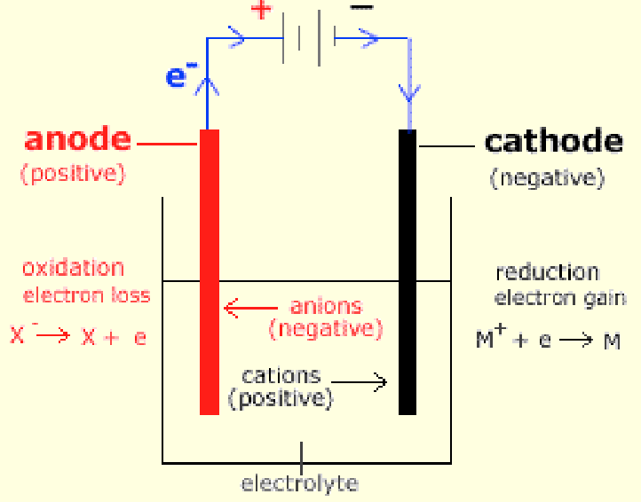
Fig. 1 Mechanism of Electrolysis
The required product of electrolysis are in different physical states from the electrolyte and can be removed by some physical processes. For example, in the electrolysis of brine to produce hydrogen and chlorine, the products are gaseous. These gaseous products bubble from the electrolyte and are collected.
Rules for electrolysis
1. Metals, if produced, are discharged at the cathode
2. Hydrogen is produced at the cathode only when reactive metals are present
3. Non-metals, apart from hydrogen, are produced at the anode
4. Reactive metals, those above hydrogen in the reactivity series, are not discharged
5. The products depend on the concentration of the electrolyte in the solution and the nature of the electrode
6. If halide ions (Cl⁻, Br⁻, I⁻) are present in reasonable concentrations, they will be discharged more readily than hydroxide ions, but if no halide ions are present, hydroxide ions are discharged more readily than other ions.
In general, metals or hydrogen gas are discharged at the cathode while non-metals (except hydrogen) are discharged at the anode.
Examples of Electrolysis
Electrolysis of Acidified Water: Acidified water (dilute tetraoxosulphate (vi) acid) is made by adding a few drops of tetraoxosulphate (vi) acid to water.
Acidified water contain the following:
 | H₂SO₄ | H₂O
Cathions | 2H⁺ (aq) | H⁺ (aq)
Anions | ${SO}_{4}^{2-}$ (aq) | OH⁻ (aq)
Concentration of ions | High | Low
Position in the electrochemical series | OH⁻ is higher than ${SO}_{4}^{2-}$

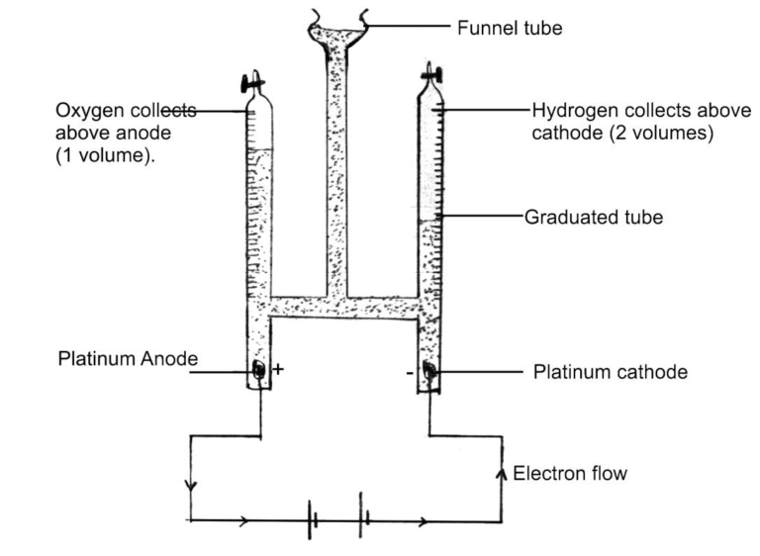
Fig.2 Electrolysis of acidified water
At the Cathode: The H⁺ ions migrate to the cathode where they acquire an electron each to form neutral hydrogen atoms. These atoms then combine in pairs to produce diatomic molecules of gaseous hydrogen.
H⁺(aq) + e⁻ $⇨$ H
H + H $⇨$ H₂(g)
At the anode: Both ${SO}_{4}^{2-}$ and OH⁻ migrate to the anode, where OH⁻
are preferentially discharged. Each OH⁻ loses its electron to the anode to become a neutral – OH group. Two – OH groups react to form one molecule of water and one atom of oxygen. Gaseous oxygen is produced when the oxygen atoms combine in pairs to form diatomic molecules.
𝑂𝐻 ⁻( 𝑎𝑞) $⇨$𝑂𝐻 + 𝑒 −
𝑂𝐻 + 𝑂𝐻 $⇨$ 𝐻₂ 𝑂 (aq) + 𝑂
𝑂 + 𝑂 $⇨$ 𝑂₂( 𝑔)
Summary
Cathodic Half-reaction: 4 𝐻⁺ (𝑎𝑞) + 4 𝑒 −$⇨$2 𝐻₂( 𝑔)
Anodic half-reaction: 4 𝑂𝐻 ⁻ (𝑎𝑞) $⇨$2𝐻₂ 𝑂 (𝑙) + 𝑂₂ (𝑔) + 4 𝑒 −
Overall reaction: 4𝐻⁺ (aq)+ 4 𝑂𝐻 ⁻( 𝑎𝑞) $⇨$ 2 𝐻₂ (𝑔) + 𝑂₂ (𝑔) + 2 𝐻₂ 𝑂( 𝑙)
The electrolysis of acidified water yields 2 volumes of hydrogen at the cathode and 1 volume of oxygen at the anode, i.e. the ratio of hydrogen to oxygen by volume is2:1.
Other examples includes: electrolysis of copper solution with copper electrodes, electrolysis of copper solution with platinum electrodes, etc.
The device used in studying the flow of current through a liquid is called voltameter.
Application.
Electrolysis is used in electroplating of metal, calibration of an ammeter, purification of impure metals and electrolytic production of metals from their compounds or ores and anodizing of metals.
FARADAY’S LAWS OF ELECTROLYSIS
Several versions of the laws can be found in textbooks and in scientific literature.
Faraday's 1st law state that the mass (M) of a substance liberated in electrolysis is directly proportional to the quantity of electricity(Q) which has passed through the electrolyte.
M $∝$ Q ……………………… (1)
M $∝$ It ……………………… (2) where Q = It
M = ZIt ……………………… (3)
Where Q is the quantity of electricity in coulombs, I is the current in ampere, t is the time in seconds and Z is a constant called electrochemical equivalent in g/C which is defined as the mass in grams of a substance liberated by the passage of 1 coulomb of electricity.
Faraday's 2nd law states that the masses of different substance deposited or liberated by the same quantity of electricity are directly proportional to the chemical equivalents of the substances.
Ex. 1. Compute the mass of copper deposited on the cathode of a copper voltameter if a current of 0.62A is passed through it for 35 minutes (Z of copper = 3.3x10⁻⁴ g/C).
Solution. Using Faraday's 1st law:
M = Zit
= 3.3x10⁻⁴ x0.62x35x60
= 0.437g
Ex. 2. Find the time in minutes required to electroplate an article of area 250 cm² with a layer of copper 0.08cm thick if a constant current of 3A is maintained . Assume that the density of copper is 8.8g/cm⁻³ and that one coulomb liberates 0.00045g of copper.
Solution.
Total vol. of copper deposited = area x thickness = 250x0.08 = 20 cm⁻³
Mass of copper = vol. x density = 20x8.8 = 176g
From M = Zit
t = M/ZI = 176/(0.00045x3) = 1.3x10⁵ secs = 2.17x10³ minutes

MAGNETIC FIELD
Magnetism is the ability of a magnet to attract magnetic substances.
A magnet is a piece of material (such as iron, nickel or cobalt) which has properties of attracting other pieces of this material.
The magnetic properties of a magnet appear to originate at certain regions in
the magnet which are referred to as the poles. In a bar magnet the poles are
the ends.
Some experimental findings about magnets
(i) Poles are of two kinds (North, N and South, S), fig.1
(ii) Like poles repel each other and unlike poles attract, fig. 2
(iii) Poles always seem to occur in equal and opposite pairs, and
(iv) When no other magnet is near, a freely suspended magnet sets so that the line joining its poles (i.e its magnet axis) is approximately parallel to the earth’s north – south axis.
The space surrounding a magnet where a magnetic force is experienced is called a magnetic field. These magnetic fields exists through all space and are created by magnetic particles and by moving electric charge.
The direction of a magnetic field at a point is taken as the direction of the force that acts on a north magnetic pole there detected using compass needle.
A magnetic field can be represented by magnetic field lines drawn so that:
(i) The line (or the tangent to it if is curved) gives the direction of the field at that point, and
(ii) The number of lines per unit cross-section area is proportional to the magnitude of the magnetic field and is an indication of the “strength” of the field.
Arrow on the lines show the direction of the field and since a north pole is repelled by the north pole of a magnet and attracted by the south, the arrows point away from the north poles and toward south poles.
Fig.1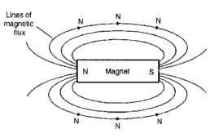

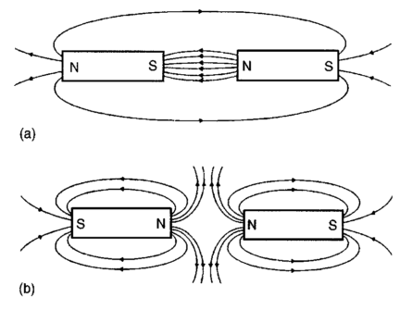
Fig.2
Similarities and Differences between Electric and Magnetic Fields
Similarities: Both fields originate in electric charges, and both fields can exert forces on electric charges.
Differences: All electric charges give rise to electric fields, but only a charge in motion relative to an observer gives rise to a magnetic field. Electric field exert forces on all charges, but magnetic fields exert forces only on moving charges.
Magnetic Force on a Charge moving in a Magnetic Field
Experimentally it is found that when a charged particle (either alone or as part of a current) moves through a magnetic field, a force due to the field can exert a force on the particle given by
$F_{m}=qv×B$
$= qvBsinθ$
Where q is the charge moving (Coulomb, C) with a speed v (m/s) in a magnetic field of flux density or magnetic induction B (Tesla, T) and θ is the angle between v and B
∴ Magnetic force is maximum when θ = 90◦ (i.e. v ⊥ B)
Magnetic force is minimum (0) when θ = 0◦, 180◦ (i.e. v||B)
When both magnetic field 𝐵 and an electric field E are present in a region, the force on a test charge is the vector sum of the electric and magnetic forces:
F_{tot} = q [E + (v x B)].
This relation is known as the lorentz's equation.
Ex.1: An electron in a television tube has a charge of 1.6 x 10⁻¹⁹ C and travels at 3 x 10⁷ m/s perpendicular to a field of flux density 18.5 μT. Determine the force exerted on the electron in the field.
Solution: F = qvB, q = 1.6 x 10⁻¹⁹ C, v = 3 x 10⁷ m/s, B = 18.5 μT = 18.5 x 10⁻⁶ T, F = ?
F = 1.6 x 10⁻¹⁹ x 3 x 10⁷ x 18.5 x 10⁻⁶ = 1.6 x 3 x 18.5 x 10⁻¹⁸
= 88.8 x 10⁻¹⁸ = 8.88 x 10⁻¹⁹ N
Ex. 2: A He²⁺ ion travels at right angles to a magnetic field of 0.80T with a
velocity of 10⁵m/s. Find the magnitude of the magnetic force on the ion.
Solution: v = 10⁵m/s, 𝐵 = 0.80T, F = ?
F = qvB = 2(1.6 x 10⁻¹⁹) x 10⁵ x 0.8 = 2.56 x 10¹⁴N
Magnetic Flux and Flux Density
Magnetic flux is the amount of magnetic field (or the number of lines of force) produced by a magnetic source. The symbol for magnetic flux is $Φ$ (Greek letter ‘phi’). The unit of magnetic flux is the weber, Wb.
Magnetic flux density is the amount of flux passing through a defined area that is perpendicular to the direction of the flux:
$$Magnetic ﬂux density=\frac{Magnetic ﬂux}{area}$$
$$B= \frac{Φ}{A}$$
Where A is the area in m² and B magnetic flux density in Tesla (T).
1 Tesla = 1T=1Wb/m² = 1C moving at 1m/s experiencing 1N
1 Gauss (G) = 10⁻⁴T ≈ magnetic field on earth’s surface
Magnetomotive Force and Magnetic Field Strength
Magnetomotive force (mmf) is the cause of the existence of a magnetic flux in a magnetic circuit,
mmf, F_{m}=NI
where N is the number of conductors (or turns) and I is the current in amperes. The unit of mmf is sometimes expressed as ‘ampere-turns’. However since ‘turns’ have no dimensions, the SI unit of mmf is the ampere
Magnetic field strength (or magnetizing force),
H= NI/l -ampere per metre
Where l is the mean length of the flux path in metres.
Thus mmf=NI= Hl amperes.
For air, or any non-magnetic medium, the ratio of magnetic flux density to magnetizing force is a constant, i.e. B/H=a constant. This constant is µ0, the permeability of free space, air (or the magnetic space constant) and is
$μ_{o}=4π×{10}^{-7} Tm/A=1.257×{10}^{-6} Tm/A=4π×{10}^{-7}H/m$
For all media other than free space, B/H=$μ_{o}μ_{r}$
Where $μ_{r}$ is the relative permeability, and is deﬁned as
$$μ_{r}=\frac{flux density in material}{flux density in vacuum}$$
Ex1. A magnetic pole face has a rectangular section having dimensions 200mm by 100mm. If the total flux emerging from the pole is 150µWb, calculate the flux density.
Solution. Flux $Φ$ =150µWb=150×10⁻⁶ Wb, Cross-sectional area A= 200×100
= 20000mm² = 20000×10⁻⁶m²
$$Flux density B= \frac{Φ}{A}=\frac{150×{10}^{-6}}{20000×{10}^{-6}}=0.0075T=7.5mT$$
Ex. 2. A magnetizing force of 8000A/m is applied to a circular magnetic circuit of mean diameter 30cm by passing a current through a coil wound on the circuit. If the coil is uniformly wound around the circuit and has 750 turns, find the current in the coil.
Solution. H=8000A/m; l= 2πr =πd=π×30×10⁻²m; N=750turns
Since H= NI/l
Then ,I= Hl/N= 8000×π×30×10⁻²/750
Thus, current I=10.05A
Ex. 3. A coil of 300turns is wound uniformly on a ring of non-magnetic material. The ring has a mean circumference of 40cm and a uniform cross-sectional area of 4cm².If the current in the coil is 5A,calculate (a) the magnetic field strength, (b) the flux density and (c) the total magnetic flux in the ring.
Solution.
(a) Magnetic field strength H= NI/l =300×5/40×10−2 =3750A/m
(b) For a non-magnetic material µ_{r} = 1,thus flux density
B = µ₀H = 4π×10⁻⁷×3750 = 4.712mT
(c) Flux$Φ$ =BA=(4.712×10⁻³)(4×10⁻⁴) = 1.885µWb
Reluctance
Reluctance S (or R_{M}) is the ‘magnetic resistance’ of a magnetic circuit to the presence of magnetic flux.
Reluctance, $S=\frac{F_{M}}{Φ}=\frac{NI}{BA}=\frac{l}{(B/H)A}=\frac{l}{μ_{o}μ_{r}A}$
The unit of reluctance is 1/H (or H⁻¹) orA/Wb
Ferromagnetic materials have a low reluctance and can be used as magnetic screens to prevent magnetic fields affecting materials within the screen.
Hysteresis and Hysteresis Loss
Hysteresis is the ‘lagging’ effect of flux density B whenever there are changes in the magnetic field strength H. When an initially unmagnetized ferromagnetic material is subjected to a varying magnetic field strength H, the flux density B produced in the material varies as shown in Fig. A, the arrows indicating the direction of the cycle. Fig. A. is known as a hysteresis loop.
Fig. A.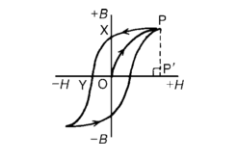
From Fig .A, distance OX indicates the residual flux density or remanence, OY indicates the coercive force, and PP′ is the saturation flux density.
Hysteresis results in a dissipation of energy which appears as a heating of the magnetic material. The energy loss associated with hysteresis is proportional to the
area of the hysteresis loop.
Tutorial II
1. Calculate the force exerted on a charge of 2 x 10⁻¹⁸C travelling at 2 x 10⁶m/s perpendicular to a field of density 2 x 10⁻⁷T.
2. Determine the speed of a 10⁻¹⁹C charge travelling perpendicular to a field of flux density 10⁻⁷T, if the force on the charge is 10⁻²⁰N.
3. The maximum working flux density of a lifting electromagnet is 1.8 T and the effective area of a pole face is circular in cross-section. If the total magnetic flux produced is 353mWb, determine the radius of the pole face.
4. An iron ring of mean diameter 10cm is uniformly wound with 2000turns of wire. When a current of 0.25A is passed through the coil a flux density of 0.4T is setup in the iron. Find (a) the magnetizing force and (b) the relative permeability of the iron under these conditions.
Magnetic Field of a Straight Conductor
The magnetic field a distance s from a long, straight current I has the magnitude
$B=\left(\frac{μ}{2π}\right)\left(\frac{I}{s}\right)$ straight current.
Where $μ$ is the permeability of the medium in which the magnetic field exists. The permeability of free space (air) $μ_{o}$.
The field lines of the magnetic field around a straight current are in the form of concentric circles around the current (fig.1). The direction of the field depends on the direction of the current and can be obtained by applying Right Hand Grip Rule or Clenched Fist Rule:
If the straight wire is grasped with the right hand so that the thumb points in the direction of the current, then the direction in which the fingers are curled, indicate the direction of the magnetic field (fig.2).
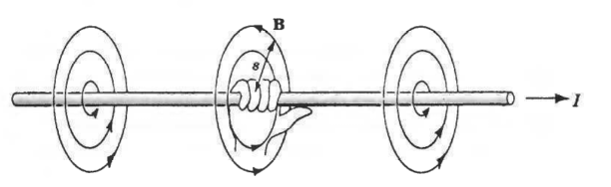
Fig.2
Magnetic Field of a Current Loop
The magnetic field at a center of a current loop of radius r has the magnitude
$B=\left(\frac{μ}{2}\right)\left(\frac{I}{r}\right)$ current loop
A Solenoid is a coil consisting of many loops of wire. If the turns are closed together and the solenoid is long compared with its diameter, the magnetic field inside it is uniform and parallel to the axis with magnitude
$B=μ\left(\frac{N}{L}\right)I$ Solenoid
Where N is the number of turns, L is the length of solenoid, and I is the current. The direction of B is as shown in fig. 3
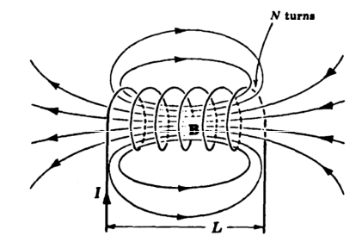
Fig. 3
An electromagnet, based on the solenoid, provides the basis of many items of electrical equipment, examples of which include electric bells, relays, lifting magnets and telephone receivers.
Earth Magnetic Field
The earth has a magnetic field that arises from the electric current in its liquid iron core. The field is like that which would be produced by a current loop centred a few hundred miles from the earth's center whose plane is tilted by 11⁰ from the plane of the equator. The geomagnetic poles are the are the points where the magnetic axis passes through the earth's surface (fig. 4). The magnitude of the magnetic field varies from place to place.
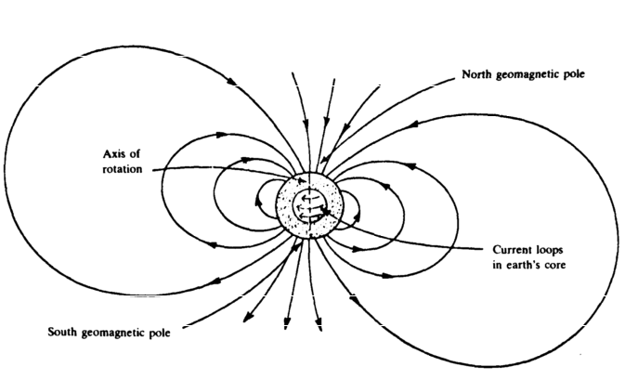
Fig. 4
Ex. 1: A cable 5m above the ground carries a current of 100A from east to west. Find the direction and magnitude of the magnetic field on the ground directly beneath the cable. (Neglect the earth's magnetic field.)
Solution: From the right hand rule, the direction of the field is south. The magnitude of the field is
$B=\left(\frac{μ}{2π}\right)\left(\frac{I}{s}\right)=\frac{4π×{10}^{-7}×4 }{2π×5}=4×{10}^{-6}T$
Ex.2: A 100-turn flat circular coil has a radius of 5cm. Find the magnetic field at the center of the coil when the current is 4A.
Solution: $B=\left(\frac{μ}{2π}\right)\left(\frac{NI}{r}\right)=\frac{100×4π×{10}^{-7}×4 }{2π×5×{10}^{-2}}=1.6×{10}^{-3}T$
Ex. 3: A solenoid 0.2m long has 1000 turns of wire and is oriented with its axis parallel to earth's magnetic field at a place where the latter is $2.5×{10}^{-5}T.$ What should the current in the solenoid be in order that its field exactly cancel the earth's field inside the solenoid?
Solution: For air-core solenoid,
$B=μ_{o}\left(\frac{N}{L}\right)I$
$I=\frac{BL}{μ_{o}N}=\frac{2.5×{10}^{-5}×0.2}{4π×{10}^{-7}×{10}^{3}}=0.004A$
Magnetic Force on a Current-carrying Wire
Since a current consist of moving charges, a current-carrying wire will experience no force when parallel to B and maximum when perpendicular to B. The force on the current-carrying conductor in a magnetic field depends upon:
(a) the flux density of the ﬁeld, B teslas
(b) the strength of the current, I amperes,
(c) the length of the conductor perpendicular to the magnetic field, l metres, and
(d) the directions of the field and the current. The force is
$F=BIL$ (I is perpendicular to B)
Otherwise $F=BILsinθ$
Where $θ$is the angle between I and B. The direction of the force exerted on a conductor can be pre-determined by using Fleming’s left-hand rule (often
called the motor rule) which states:
Let the thumb, first finger and second finger of the left hand be extended such that they are all at right-angles to each other (as shown in Fig. 5a). If the first finger points in the direction of the magnetic field, the second finger points in the direction of the current, then the thumb will point in the direction of the motion of the conductor. Also the direction of the force is as shown in fig. 5b.
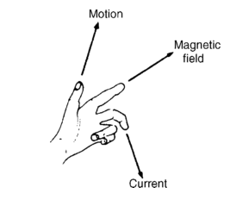
Fig. 5a.
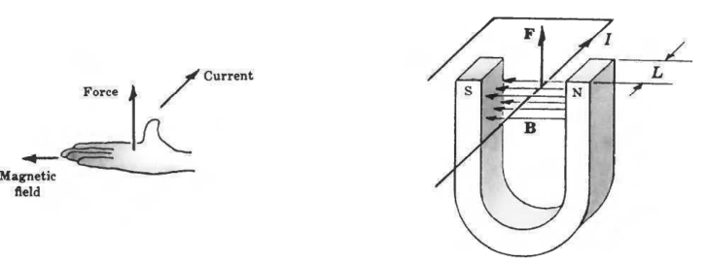
Fig. 5b.
A simple application of the above force is the moving coil instrument and electric motor.
Ex.1. A conductor carries a current of 20A and is at right-angles to a magnetic field having a flux density of 0.9T. If the length of the conductor in the field is 30cm, calculate the force acting on the conductor. Determine also the value of the force if the conductor is inclined at an angle of 30◦ to the direction of the field.
Solution. B= 0.9T; I= 20A; L= 30cm= 0.30m
Force F=BIl=(0.9)(20)(0.30) =5.4N
But when θ = 30◦,
F=BILsinθ =(0.9)(20)(0.30) sin 30◦ = 2.7N
Ex.2. Determine the current required in a 400mm length of conductor of an electric motor, when the conductor is situated at right-angles to a magnetic field of flux density 1.2T, if a force of 1.92N is to be exerted on the conductor.
Solution. Force= 1.92N; L = 400mm= 0.40m; B= 1.2T
Since F= BIL, then
hence current I = F/BL = 1.92/(1.2)(0.4)= 4A
Ex.3. A conductor 350mm long carries a current of 10A and is at right-angles to a magnetic field lying between two circular pole faces each of radius 60mm. If the total flux between the pole faces is 0.5mWb,calculate the magnitude of the force exerted on the conductor.
Force Between two current-carrying wires
Two parallel electric current exert force on each other(fig. 6). If the currents are in the same direction, the forces are attractive; if the currents are in opposite direction the forces are repulsive. The force per unit length F/L on each wire depends on the currents I₁ and I₂ and their separation s:
$\frac{F}{L}=\left(\frac{μ_{o}}{2π}\right)\left(\frac{I_{1}I_{2}}{s}\right)$
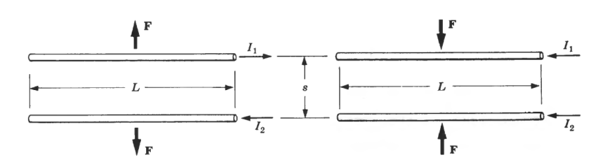
Fig. 6
HALL’S EFFECT
As proved that a beam of electrons in a vacuum can be deflected by a magnetic field so also the drifting conduction electrons in a copper wire can be deflected by a magnetic field as discovered by Edwin H. Hall in 1879.
Fig.7.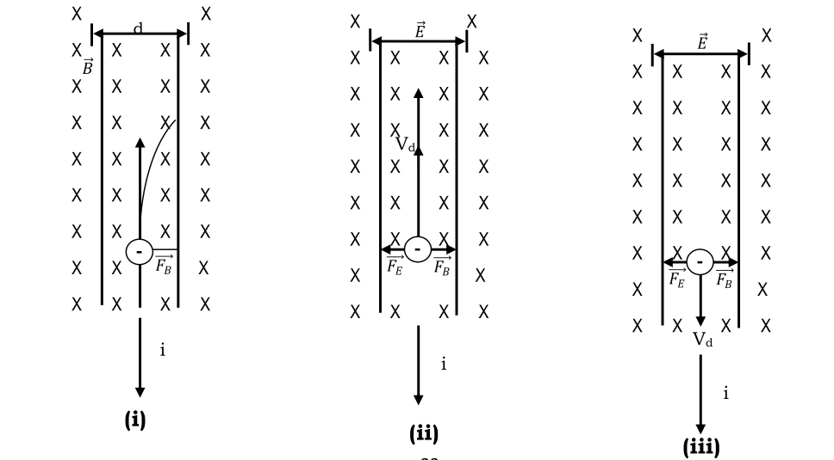
Fig (i) shows a copper strip carrying a current i whose direction is from the top to the bottom of the figure. If there is any external magnetic field 𝐵 , pointing into the plane of the figure, we see that the deflecting force 𝐹_{𝐵} will act on each electron drifting it toward the right edge of the strip. As time passes electron pill at the right leaving the left negative. The separation of positive and negative charges produce an electric field 𝐸 with the strip, pointing left. As time continues to pass by equilibrium develops and the force due to 𝐵 and that due to 𝐸 balances each other allowing the electrons to drift out without further increase in 𝐸 .
By connecting a voltmeter across the width of the strip, we can measure the Hall potential difference between the two edges of the trip.
The separation of charge in the wire as result of external magnetic field is called the Hall Eﬀect.
Suppose V_{H} is the magnitude of the Hall voltage and d is the width of the strip. Then the electric field strength E set up across the strip is
E = V_{H}/d (1).
Now when the electric and magnetic forces are in equilibrium,
eE = eV_{d}B (2)
However drift velocity is V_{d} = 𝐽/𝑛 𝑒 =𝑖/𝑛𝑒A (3)
Where J = i/A is the current density of the strip, A is the crosss-sectional area of the strip and n is the number density of charge carriers.
If we put equation (2) and equation (3) into equation (2) we get:
$E=V_{d}B$
$\frac{V_{H}}{d}=\frac{iB}{neA}$
$V_{H}=\frac{iBd}{neA}$
$V_{H}=\frac{iB}{ne}{\left(\frac{A}{d}\right)}^{-1}$

In which 1(=A/d) is the thickness of the strip.
$$V_{H}=\frac{iB}{ne}{\left(l\right)}^{-1}$$
$V_{H}=\frac{iB}{nel}$ (4) Hall potential difference
$n=\frac{iB}{V_{H}el}$ number of density charge carriers
It has many applications nowadays in the area of Hall probes, Hall effect sensors, etc.
MAGNETIC PROPERTIES OF MATTER
Magnetism is a property of matter and it occurs in different forms and degree in various conductors and insulators. The degree of magnetism of a substance is due to the intrinsic magnetic dipole moments of its electrons. The degree of magnetism is also called magnetization and it is defined as the net magnetic dipole moment of the substance per unit volume.
Faraday had shown that all materials can be magnetized, weakly or strongly, when subjected to a strong magnetizing field. They may, however, be divided into three categories.
(i) Diamagnetic
(ii) Paramagnetic and
(iii) Ferromagnetic materials.
Diamagnetic substance have a negative magnetic susceptibility, (i.e. they are materials in which the magnetization and magnetic field are opposite). The electrons in the atom of diamagnetic materials are all paired and there is no intrinsic Magnetic moment. When a material is placed into a magnetic field, its atoms acquire an induced magnetic moment pointing in a direction opposite to that of the external field and the material becomes magnetic. The diamagnetic field produced by the material opposes the external field, although this diamagnetic field is very weak (except in superconductors). Examples of diamagnetic material are Bismuth, Cadmium, Copper,
Germanium, Gold, Lead and Zinc.
NB: If the atoms of a material have no magnetic moment of their own, then diamagnetism is the only magnetic property of the material and the material is called diamagnetic. Copper exhibits such diamagnetism.
Paramagnetic substance has a weak positive magnetic susceptibility resulting from the presence of atoms (or ions) that have permanent magnetic moments. These moments interact only weakly with each other and are randomly oriented in the absence of an external magnetic field. When a paramagnetic substance is placed in an external magnetic field, its atomic moments tends to line up with the field. However, this alignment process must compete with thermal motion, which tends to randomize the magnetic moment orientation. If only a relatively small fraction of the atoms are aligned with the field, then the magnetization obeys Curie's law.
Curie's Law states that the magnetization of a paramagnetic substance is proportional to the applied magnetic field and inversely proportional to the absolute temperature.
$M=C\frac{B_{o}}{T}$ … ……. (1)
Where C = Curie's constant, Bo = Magnetic field, T = absolute temp,
M = Magnetization
The law shows that when Bo = O, the magnetization is Zero, corresponding to a random orientation of magnetic moments. As the ratio of magnetic field to temperature becomes great, the magnetization approaches its saturation value corresponding to a complete alignment of its moments and equation is no longer valid. When the temp. of a ferromagnetic substance reaches or exceeds critical temp. called the curie temperature, the substance loses its residual magnetization and becomes paramagnetic. Below the Curie temp., the magnetic moments are aligned and the substance is ferromagnetic. Above the Curie temp., the thermal agitation is great enough to cause a random orientation of the moments, and the substance becomes paramagnetic.
Examples of paramagnetic materials are aluminium, antimony, chromium manganese, platinum, tantalum, alum, and gadolinium. In general, the transition elements and rare earth metals are paramagnetic.
Ferromagnetic substance have the highest magnetic susceptibility. These substance contain atomic magnetic moment that tend to align parallel to each other even in a weak external magnetic field. Once the moments are aligned the substance remains magnetized after the external field is removed. This permanent alignment is due to a strong coupling between neighbouring moments, a coupling that can be understood only in quantum – mechanical terms.
They comprise iron, nickel, cobalt , gadolinium and certain alloys. All ferromagnetic materials are made up of microscopic regions called domains, region within which all magnetic moments are aligned. These domains have volumes of about 10⁻¹² to 10⁻⁸and contain10¹⁷ to 10²¹ atoms. The bounders between the various domains having different orientations are called domain walls. In an unmagnetized sample, the domains are randomly oriented so that the net magnetic moment is zero as shown in fig. 1.0(a).
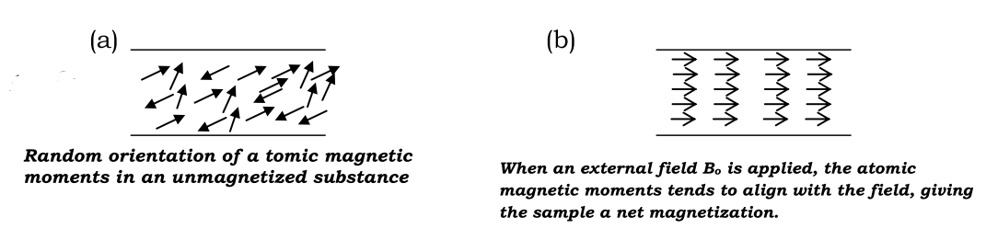
Fig.8.
When the sample is placed in an external magnetic field, the magnetic moments of the atoms tends to align with the field, which results in a magnetized sample. Some examples of ferromagnetic substance are, iron, cobalt, nickel, gadolinium and dysprosium.
ELECTROMAGNETIC INDUCTION
When a conductor is moved across a magnetic field so as to cut through the lines of force (or flux), an electromotive force (e.m.f.) is produced in the conductor. If the conductor forms part of a closed circuit then the e.m.f. produced causes an electric current to flow round the circuit. Hence an e.m.f. (and thus current) is ‘induced’ in the conductor as a result of its movement across the magnetic field. This effect is known as ‘electromagnetic induction’.
Fig.1(a) shows a coil of wire connected to a centre-zero galvanometer, which is a sensitive ammeter with the zero-current position in the centre of the scale.
(a) When the magnet is moved at constant speed towards the coil (Fig.1(a)), a deflection is noted on the galvanometer showing that a current has been produced
in the coil.
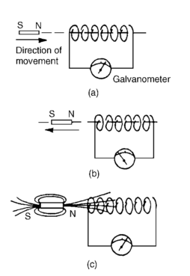Fig.1
(b) When the magnet is moved at the same speed as in (a) but away from the coil the same deflection is noted but is in the opposite direction (Fig. 1(b)).
(c) When the magnet is held stationary, even within the coil, no deflection is recorded.
(d) When the coil is moved at the same speed as in (a) and the magnet held stationary the same galvanometer deflection is noted.
(e) When the relative speed is, say, doubled, the galvanometer deflection is doubled.
(f) When a stronger magnet is used, a greater galvanometer deflection is noted.
(g) When the number of turns of wire of the coil is increased, a greater galvanometer deflection is noted.
Fig. 1(c) shows the magnetic field associated with the magnet. As the magnet is moved towards the coil, the magnetic flux of the magnet moves across, or cuts,
the coil. It is the relative movement of the magnetic flux and the coil that causes an e.m.f. and thus current, to be induced in the coil.
Laws of Electromagnetic Induction
Faraday’s Laws of Electromagnetic Induction state:
(i) ‘An induced e.m.f. is set up whenever the magnetic field linking that circuit changes.’
(ii) ‘The magnitude of the induced e.m.f. in any circuit is proportional to the rate of change of the magnetic flux linking the circuit.’
Lenz’s law states:
‘The direction of an induced e.m.f. is always such that it tends to set up a current opposing the motion or the change of flux responsible for inducing that e.m.f.’.
An alternative method to Lenz’s law of determining relative directions is given by Fleming’s Right-hand rule (often called the geneRator rule) which states:
Let the thumb, first finger and second finger of the right hand be extended such that they are all at right angles to each other (Fig.2).
If the first finger points in the direction of the magnetic field, the thumb points in the direction of motion of the conductor relative to the magnetic field, then the second finger will point in the direction of the induced e.m.f.
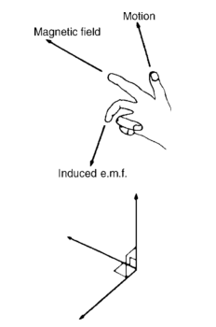Fig.2
Induced emf, E, can be dynamically induced emf as in an a. c. or d. c. generator when conductor is moving in a stationary magnetic field in such a way that magnetic flux linking it changes. OR statically induced emf as in transformer when the conductor is stationary and magnetic field is moving or changing.
Mathematically,
$$E=-\frac{d}{dt}\left(Nϕ\right)$$
$$=-N\frac{d}{dt}\left(ϕ\right)$$
Where E is the induced emf, N is the number of turns of coil and $ϕ$ is the magnetic flux.
Consider a single conductor l meters moving at right angles to a uniform magnetic field B with velocity v through a distance dx in dt seconds. Then
Magnetic flux cut, d$ϕ$ = Flux density x area swept by the conductor
= Bldx
According to faraday’s laws of electromagnetic induction, emf, E induced in the conductor is given by;
$E=N\frac{d}{dt}\left(ϕ\right)=\frac{Bldx}{dt}$ ($∵N=1)$
$∴E=Blv$ $(∵\frac{dx}{dt}=v)$
If the conductor is at angle θ to B, then
$$∴E=Blv sinθ$$
Ex. 1. A conductor 300mm long moves at a uniform speed of 4m/s at right-angles to a uniform magnetic field of flux density 1.25 T. Determine the current flowing in the conductor when (a) its ends are open-circuited, (b) its ends are connected to a load of 20 ohms resistance.
Solution.
Induced e.m.f. E= Blv= 1.25( 300/1000)(4)= 1.5V
(a) If the ends of the conductor are open circuited no current will flow even though 1.5V has been induced.
(b) From Ohm’s law,I= E/R= 1.5/20 = 0.075A = 75mA
Ex. 2. A coil of 100 turns is linked by a magnetic flux of 20mWb. If this magnetic flux is reversed in a time of 2ms, calculate the average emf induced in the coil.
Solution.
Change in magnetic flux, d $ϕ$ = 20- (-20) = 40mWb = 40 x 10⁻³ Wb.
Time taken for the change, dt = 2 x 10⁻³s
$$∴E= N\frac{d}{dt}\left(ϕ\right)=100x \frac{40 x {10}^{-3}}{2 x {10}^{-3}}=2000V$$
Inductance
Inductance is the name given to the property of a circuit whereby there is an e.m.f. induced into the circuit by the change of flux linkages produced by a current change. When the e.m.f. is induced in the same circuit as that in which the current is changing, the property is called self inductance, L. When the e.m.f. is induced in a circuit by a change of flux due to current changing in an adjacent circuit, the property is called mutual inductance, M. The unit of inductance is the henry, H.
‘A circuit has an inductance of one henry when an e.m.f. of one volt is induced in it by a current changing at the rate of one ampere per second.’
Induced e.m.f. in a coil of inductance L henrys,
$$E= -L\frac{dI}{dt}$$
Where dI is the change in current in amperes and dt is the time taken for the current to change in seconds (i.e. dI/dt is the rate of change of current). The minus sign indicates its direction (given by Lenz’s law).
Ex. 1. Calculate the e.m.f. induced in a coil of inductance 12 H by a current changing at the rate of 4A/s.
Solution.
$E= -L\frac{dI}{dt}$ = -12 x 4 = -48V
Inductors
A component called an inductor is used when the property of inductance is required in a circuit. The basic form of an inductor is simply a coil of wire.
Factors which affect the inductance of an inductor include:
(i) the number of turns of wire — the more turns the higher the inductance
(ii) the cross-sectional area of the coil of wire — the greater the cross-sectional area the higher the inductance
(iii) the presence of a magnetic core — when the coil is wound on an iron core the same current sets up a more concentrated magnetic field and the inductance is increased
(iv) the way the turns are arranged — a short thick coil of wire has a higher inductance than a long thin one.
Two examples of practical inductors are shown in Fig.3., and the standard electrical circuit diagram symbols for air-cored and iron cored inductors are shown in Fig4.
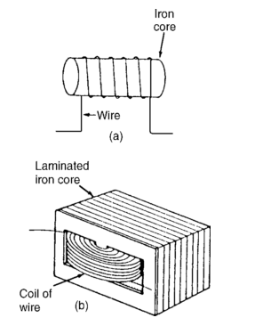fig. 3
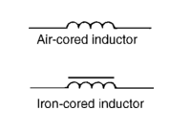
Fig. 4.
Energy Stored
An inductor possesses an ability to store energy. The energy stored, W, in the magnetic field of an inductor is given by:
$$W=\frac{1}{2}LI^{2} joules$$
Tutorial IV
1. A conductor moves with a velocity of 15m/s at an angle of (a) 90◦, (b) 60◦ and (c) 30◦ to a magnetic field produced between two square-faced poles of side length 2cm.If the flux leaving a pole face is 5µWb, find the magnitude of the induced e.m.f. in each case.
2. The magnetic flux passing perpendicular to the plane of a coil and directed into the plane of the paper is varying according to the following equation:
$$ϕ=5t^{2}+6t+2$$
Where $ϕ$ is in Wb and t in seconds. Find the induced emf in the coil at t =1s.
3. A flux of 400µWb passing through a 150-turn coil is reversed in 40ms. Find the average e.m.f. induced.
DYNAMO
Dynamo is a machine that converts mechanical energy into electrical energy or electrical energy into mechanical energy. When it changes mechanical energy into electrical energy is called a GENERATOR, but when it changes electrical energy into mechanical energy, it is called a MOTOR.
Generators are classified into alternating current (A. C.) and direct current (D. C.) generator.
D. C. GENERATOR
D. C. generator is a generator that produces direct current using a commutator.
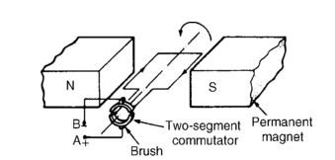
Fig. 1 D. C. generator.
Principles
A d. c. generator (fig. 1) consists of a stationary structure called stator, which provides a constant magnetic held and a set of rotating windings called armature which turn within the constant magnetic field; cutting the magnetic flux thereby creating an electric current in the wire. A commutator was needed to produce direct current because when a loop of wire rotate in a magnetic field the current produce reverses with each half turn which produces alternating current, the commutator serve as a rotary switch, it consist of a set of contacts mounted on the machines shaft combined with graphite-block station by contacts called “brushes”. The commutator reverses the connection of the windings to the external circuit when the potential reverses, therefore instead of alternating current, a direct current is produced.
Note: a D.C. generator in reverse order could work as a D.C. motor.
A. C. GENERATOR
A. C. generator (alternator) produces an alternating current with frequency base on the rotational speed of the rotor and the number of magnetic poles.
Principles
An A.C. generator is the same with D.C generator except A.C. generator does not have a commutator. A typical alternators use a rotating field (electromagnetic) winding excited with a direct current and a stationary winding (stator) to produce alternating current.
In an a.c. generator (or alternator) the alternating e.m.f is taken off and applied to the external circuit by two spring-loaded graphite blocks (called ‘brushes’) which press against two copper slip-rings. These rotate with the axle, are insulated from one another and each is connected to one end of the coil (fig. 2).
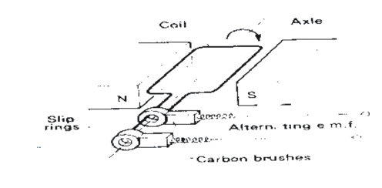
Fig. 2. A. C. generator.
TRANSFORMER
This is an electrical device used to step-up or step-down voltage in an a.c. circuit. It consist of a primary and a secondary coil wound on the same iron
Core (fig. 1.)
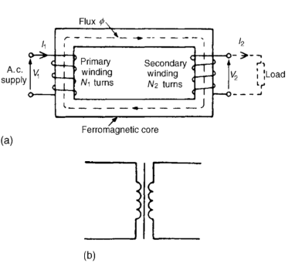
Fig. 1.
When power is supplied to one coil named the primary coil. A varying current in this coil sets up a varying magnetic flux, largely confined to the ferromagnetic core. The other coil, called the secondary coil, thus experiences a varying flux. While this flux is changing at the rate dφ/dt, each of the $N_{s}$ turns in the secondary coil experiences, according to Faraday’s laws of EMI, an induced e.m.f. equal to dφ/dt, and the e.m.f for the entire secondary coil is
$E_{s}=N_{s }\frac{dφ}{dt}$ ……………….1
We neglect the small amount of leakage flux and assume that the magnetic
flux at any instant is the same through the primary and secondary coils. Then there is an e.m.f. dφ/dt induced in each of the $N_{p}$ turns of the primary coil and the total e.m.f. for this coil is
$E_{p}=N_{p}\frac{dφ}{dt}$ …………………..2
Dividing (1) by (2) yield,
$\frac{N_{s}}{N_{p}}=\frac{E_{s}}{E_{p}}=\frac{V_{s}}{V_{p}}$ ………….(3)
Where $\frac{N_{s}}{N_{p}}$ is the turn ratio of the transformer and $\frac{V_{s}}{V_{p}}$ is the voltage ratio.
Ideal Transformer
An ideal transformer is one with no losses of any kind. i.e. a transformer with 100 percent efficiency.
Power in primary = power in secondary or
Input power = output power
${{{I_{p}V}_{p}=I}_{s}V}_{s}$ …………….. (4)
Where $I_{p}$ and $I_{s}$ are primary and secondary current respectively.
$\frac{V_{s}}{V_{p}}=\frac{I_{p}}{I_{s}}$ ………………………5
From (3) and (5),
$\frac{N_{s}}{N_{p}}=\frac{V_{s}}{V_{p}}=\frac{I_{p}}{I_{s}}$
$∴\frac{N_{s}}{N_{p}}=\frac{I_{p}}{I_{s}}$
If Ns> Np, then Vs> Vp and we have a step-up transformer.
If Ns< Np, then Vs< Vp and we have a step-down transformer.
Energy Losses in a Transformer
1. Copper or heat ( or I²R) losses – energy is lost in form of heat in the coil. It can be minimize by using a low resistant coil or thick wire.
2. Eddy current loses – magnetic flux induces current in the core, referred to as eddy currents, thereby heating up the core. Increasing the resistance of the core by the lamination of the iron core will reduce it.
3. Hysteresis loses – This happen in the transformer core since the core is taken through a cycle. The loss is dependent on the area of the hysteresis loop. Use of core made of soft magnetic core mitigate it.
4. Magnetic leakage – some magnetic flux does not pass through the iron core. It can be minimize by special forms of coil winding .
Types of Transformer
Based on construction we have broadly:
(i) Core – type transformer
(ii) Shell – type transformer
Efficiency of a Transformer
Efficiency $=\frac{secondary power}{primary power}$ x100%
$=\frac{{I_{s}V}_{s}}{{I_{p}V}_{p}}$ x100%
Ex. 1. A transformer has 500 primary turns and 3000 secondary turns. If the primary voltage is 240V, determine the secondary voltage, assuming an ideal transformer.
Solution.
For an ideal transformer, voltage ratio=turns ratio, i.e.
$\frac{N_{s}}{N_{p}}=\frac{V_{s}}{V_{p}}$
$$\frac{3000}{500}=\frac{V_{s}}{240}$$
Thus secondary voltage $V_{s}=\frac{\left(3000\right)(240)}{500}$ = 1440V = 1.44kV
Tutorial V
1. A step-up transformer operates on a 110V line and supplies a load with 5.0A. The ratio of the primary and secondary windings is 1:25. Determine :
(i) The secondary voltage (ii) The primary current and
(iii) The power output. Assume a resistive load and 100% efficiency.
2. A step-down transformer is used on a 1650V line to deliver 45A at 110V – What current is drawn from the line? Assume 100% efficiency.
3. A 5kVA single-phase transformer has a turns ratio of 10:1 and is fed from a 2.5kV supply. Neglecting losses, determine (a) the full load secondary current, (b)the minimum load resistance which can be connected across the secondary winding to give full load kVA, (c) the primary current at full load kVA.

